If you want to read a biography:

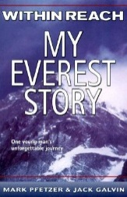
Within Reach: My Everest Story by Mark Pfetzer and Jack Galvin

If you want to read some non-fiction:

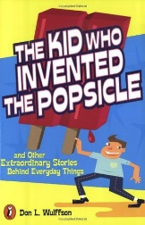
The Kid Who Invented the Popsicle: And Other Surprising Stories about Inventions by Don L. Wulffson

If you like adventure:

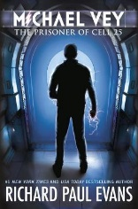
Michael Vey: The Prisoner of Cell 25 (Book 1) by Richard Paul Evans

If you want to read historical fiction:

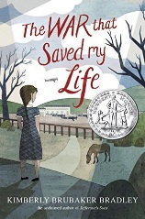
The War That Saved My Life

by Kimberly Brubaker Bradley

If you want to read a mystery:

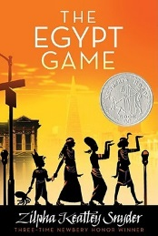
The Egypt Game

by Zilpha Keatley Snyder

Do you want some girl mystery action?

Stargirl by Jerry Spinelli

If you like fantasy:

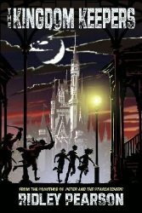
Disney after Dark

(Kingdom Keepers #1) by Ridley Pearson

Classics
- Treasure Island
- Little Women
- Jungle Book
- Adventures of Sherlock Holmes

